**RecruitmentCTF’24**

**Challenge Name:** You Can’t See Me

**Author:** Abhinav Mehta

**Domain:** Forensic

**Challenge Description:**

Just as Ravi was about to continue his walk home, his phone buzzed with a notification. It was a message from an unknown number, containing a peculiar file with a note: "Enjoyed the fair? Some files hide more than they show." Ravi's curiosity was piqued, but he decided to ignore the file and focus on the good memories of the day.

Can you uncover the hidden data within the file?

**Solution:**

****1. So you all might have got a Pdf file “challenge-file.pdf”  
so that catch here is it’s not a pdf file actually it looks like it but isn’t ..  
2. Rename the file with .zip extension.  
  
after That extract the zip you will get a folder  
  
  
opening the file you can see a pdf, an image and a readme  
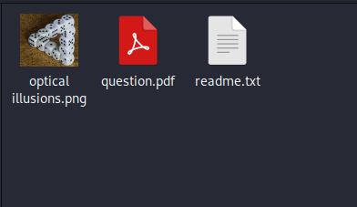

As the locked pdf we have to get the password .So for the password part you have to see the meta data of the image provided using the **exiftool** or any other online meta data extractor there you will get the password for the file which is “49 48 116 104 65 117 103 ”  
after all the numbers there is spacing so while entering enter   
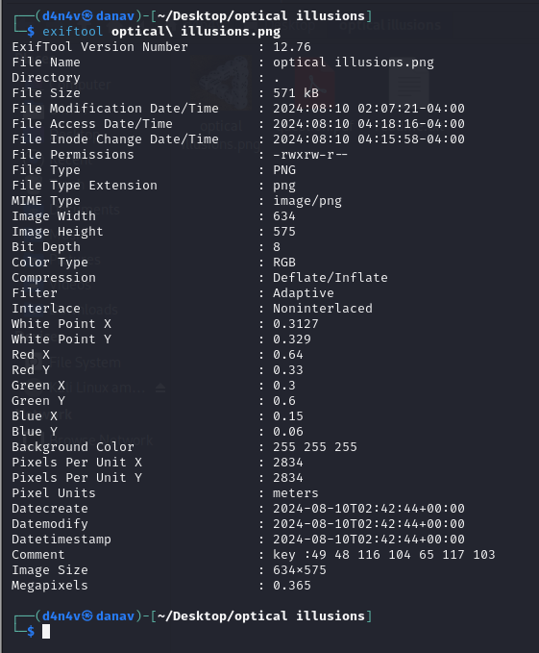

You can see the key in the comments of the meta data.  
Entering the key we can open the pdf in the folder.  
At the end of the PDF there is the flag

Final Flag is: RecruitmentCTF{POLYGLOT_H4CK3RY_1S_A_P1ECE_OF_4RT}